Programming the XC9572XL-10VQG44C v2 (includes pin assingments)
**Could not get this to work on Windows10 – had problem with programming pod drivers. Googling around, a lot of people had problems with this and reverted to Win7 or XP. I had an old XP computer laying around which worked ok.
- OBTAIN PROGRAMMING POD
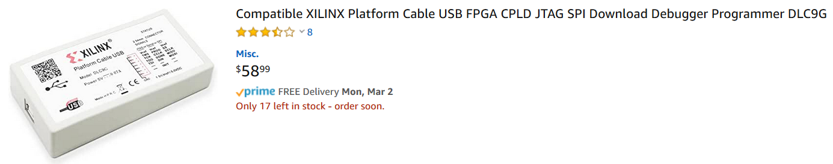
- Obtain a XC9572XL-10VQG44C
Proto advantage sells the chip on a 44-pin DIP carrier; they ship fast!
https://www.proto-advantage.com/store/product_info.php?products_id=400024


- BUILD THE PROGRAMMING BOARD – “Home-brew” LAoE style!
This is described in detail on Tom’s site:
https://learningtheartofelectronics.com/parts-lists/programming-setup-for-pld/
Link to the pdf:
https://learningtheartofelectronics.com/wp-content/uploads/2016/12/pld_programmer_board_dec16.pdf
Here is the schematic from Tom’s pdf:
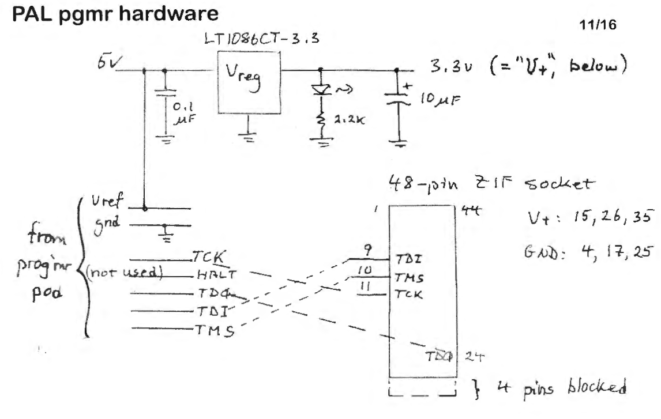

The DLC9G includes the small interface board and flying leads; board and one side of leads plugs into the pod:
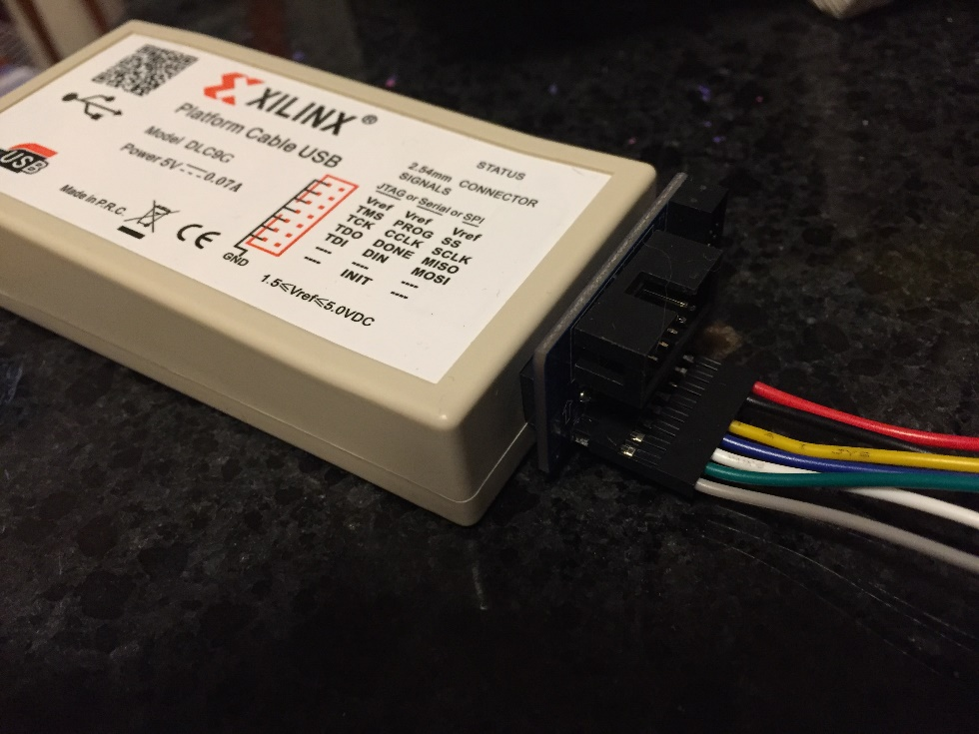

Was easier for me to layout on a breadboard, so can skip the 48 pin ZIF socket:
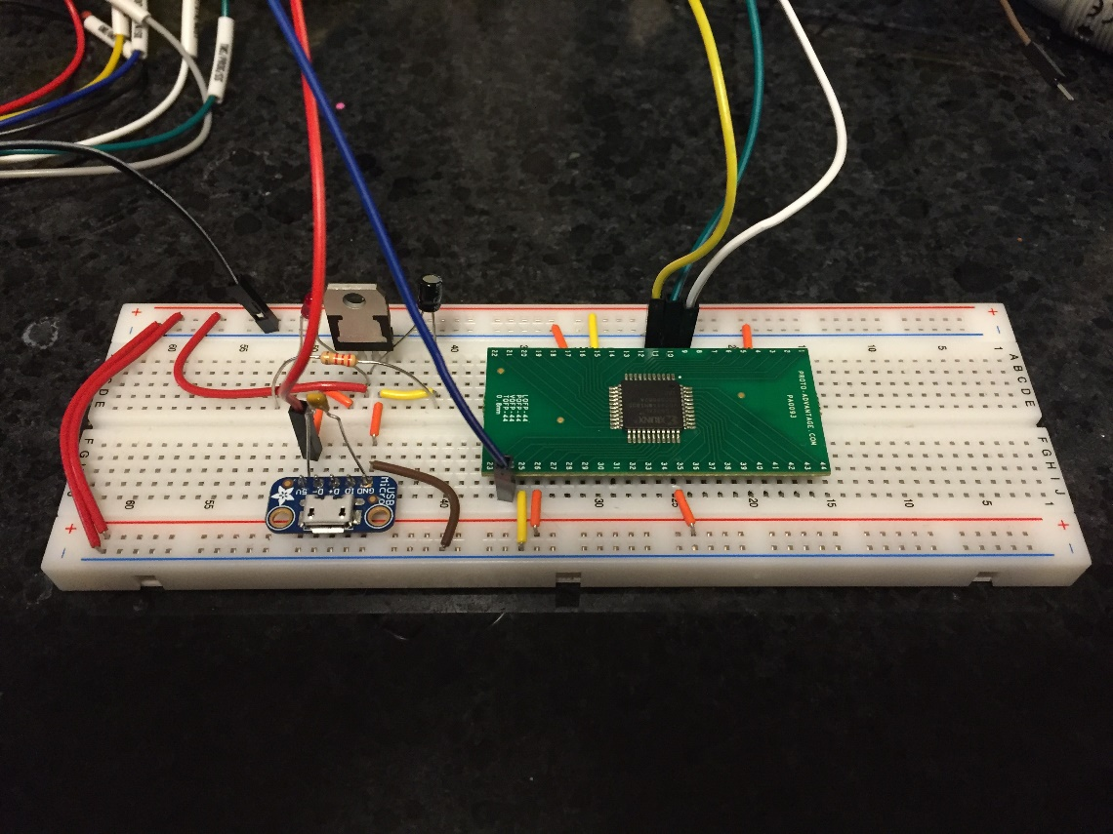
PARTS:
Handy jumper wires from amazon
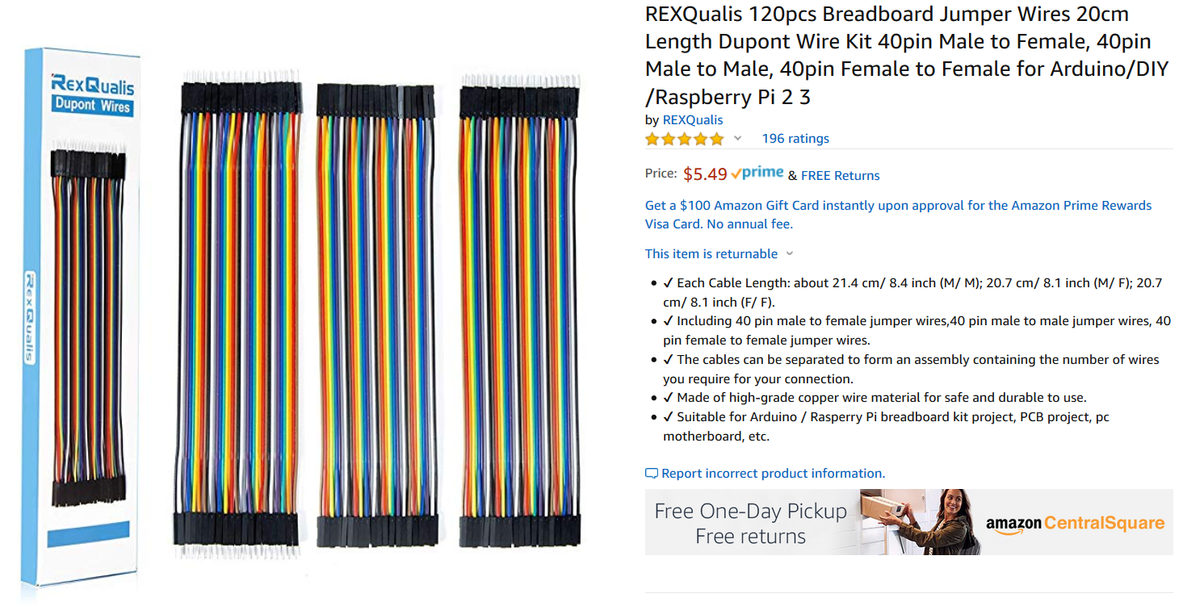
Power supply (Adafruit, #501), USB power cable and swtich (Adafruit #2379), USB Micro-B Breakout Board (#1833)
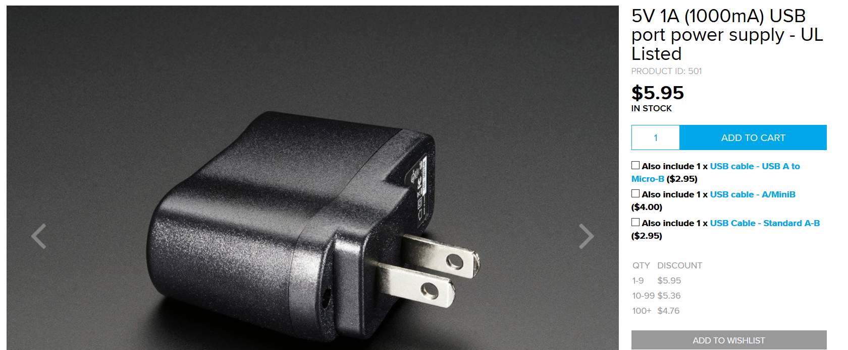
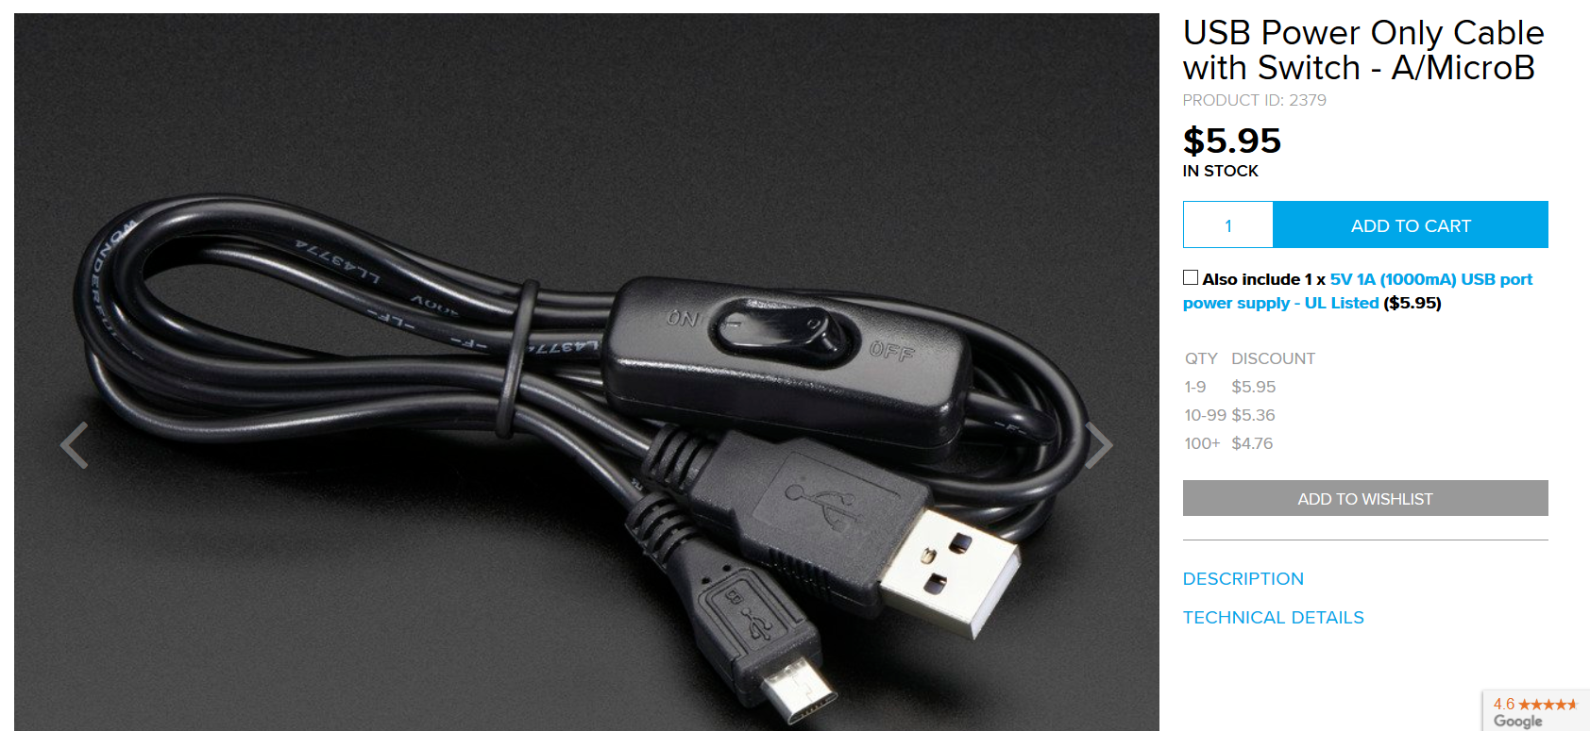
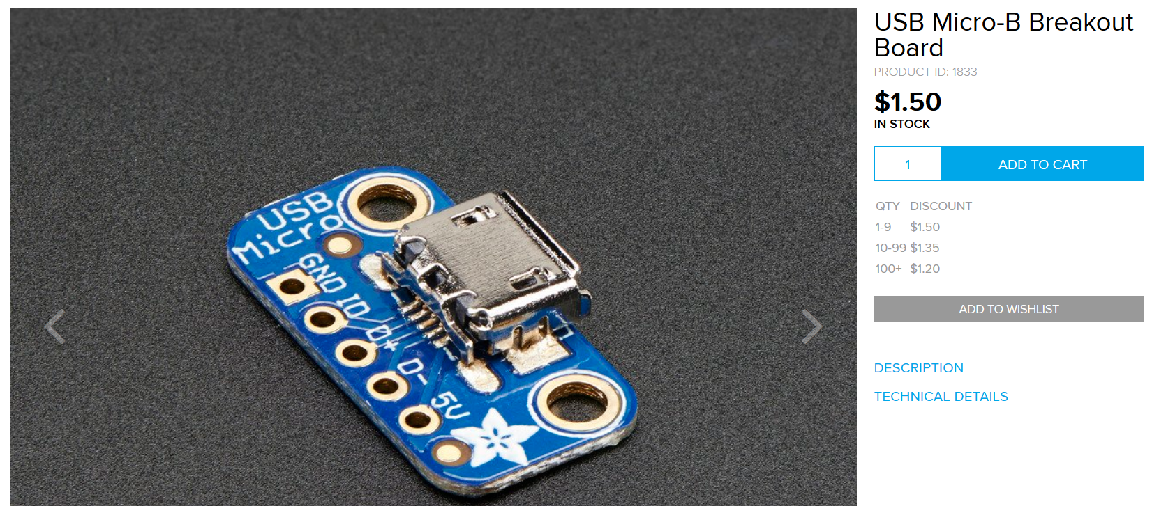
3M Jumper wire kit – a little pricey but convenient!!
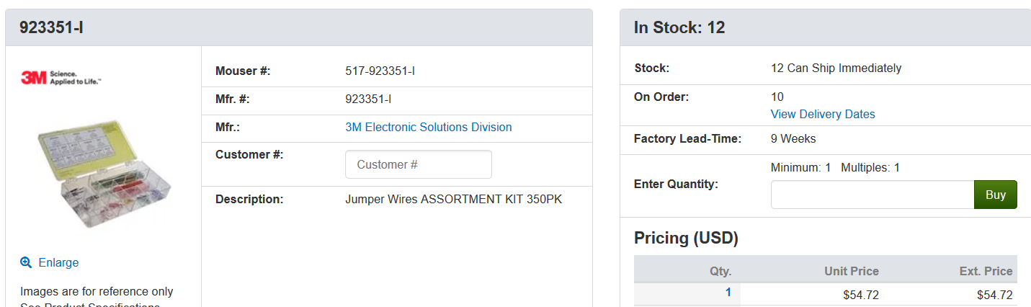
Linear regulator – I used this one
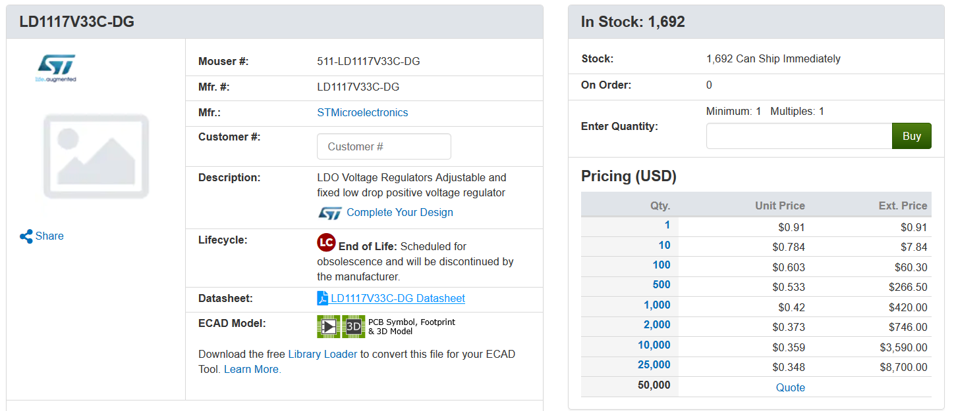
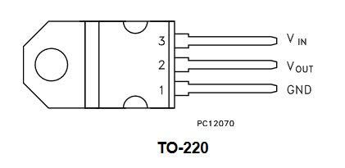
  - uF capacitor – ceramic – mouser 75-1C20Z5U104M050R
10 uF capacitor – electrolytic – longer lead positive end; mouser 667-ECE-A1CKS100
2.2 k resistor – mouser - 660-MF1/4DCT52R2201F
Red LED – mouser 604-WP424IDT
Breadboard
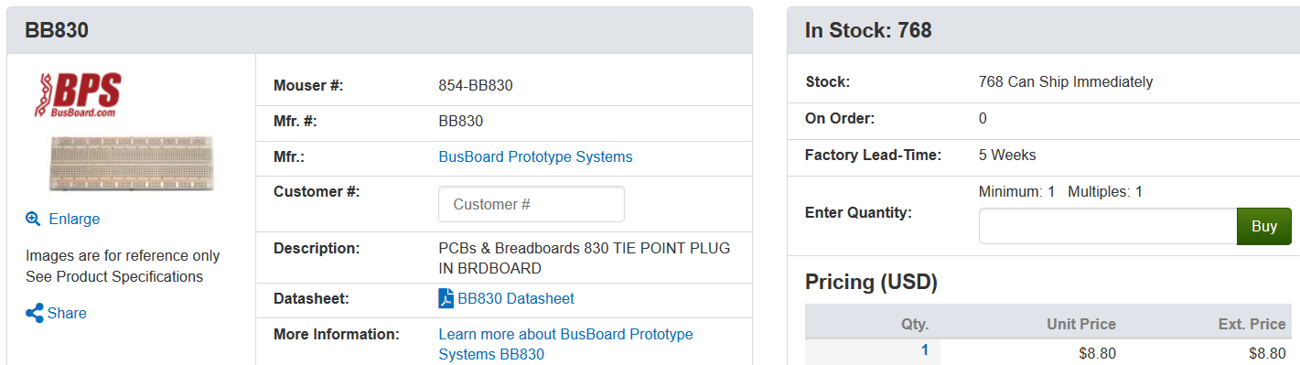
- Install Xilinx!
https://www.xilinx.com/support/download/index.html/content/xilinx/en/downloadNav/vivado-design-tools/archive-ise.html
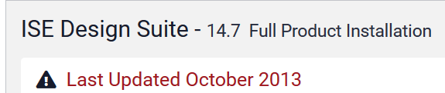
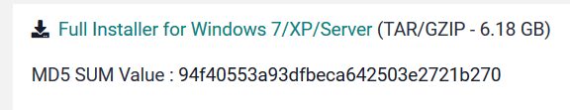
During installation, I think an option comes up where you should select “WEBPACK”.
Open project navigator.
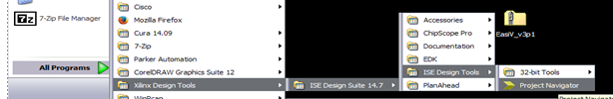
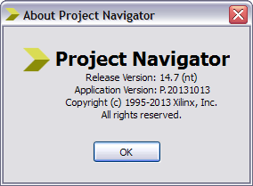
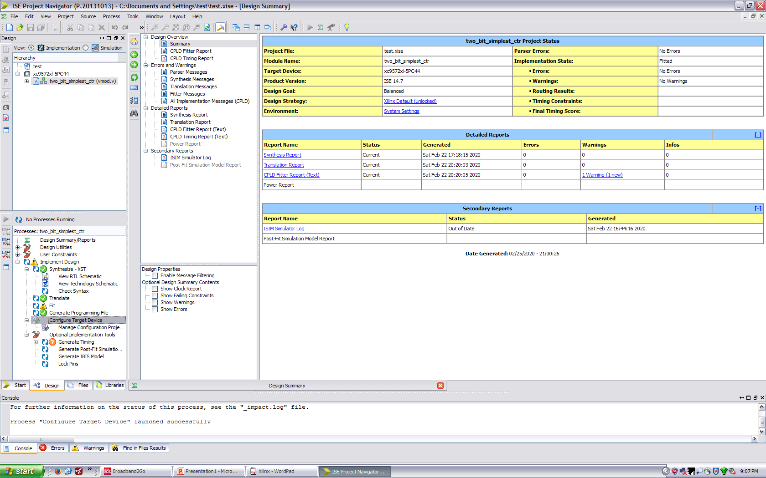

As an example, I just programmed in the voting machine code as a base and entered in simple logic for a test i.e. pro = a & b, con = a | b, allpro = a & b & c, allcon = a | b | c.

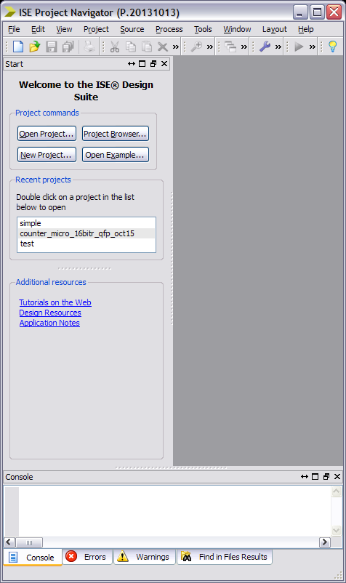 NEW PROJECT
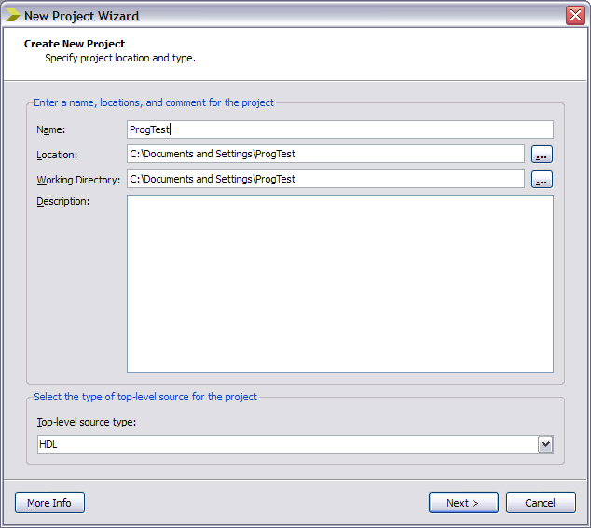

Important settings, select correct chip
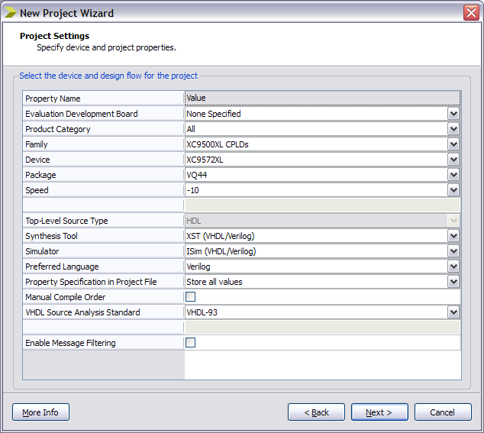

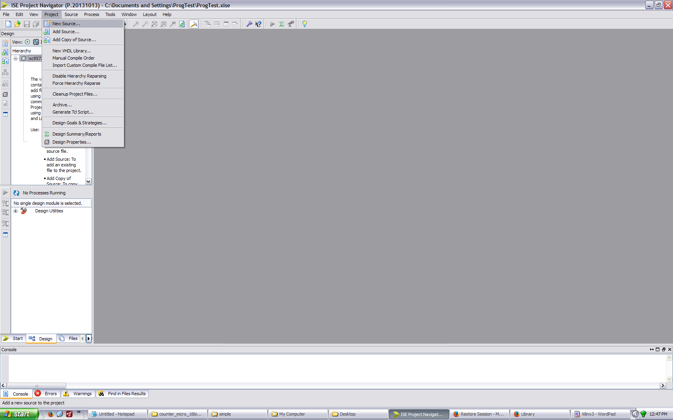 Project, add source

Add Verilog module
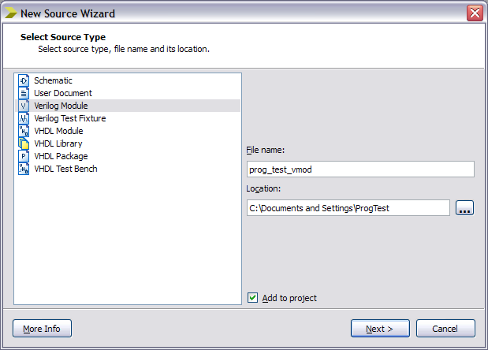

Add the code & save !
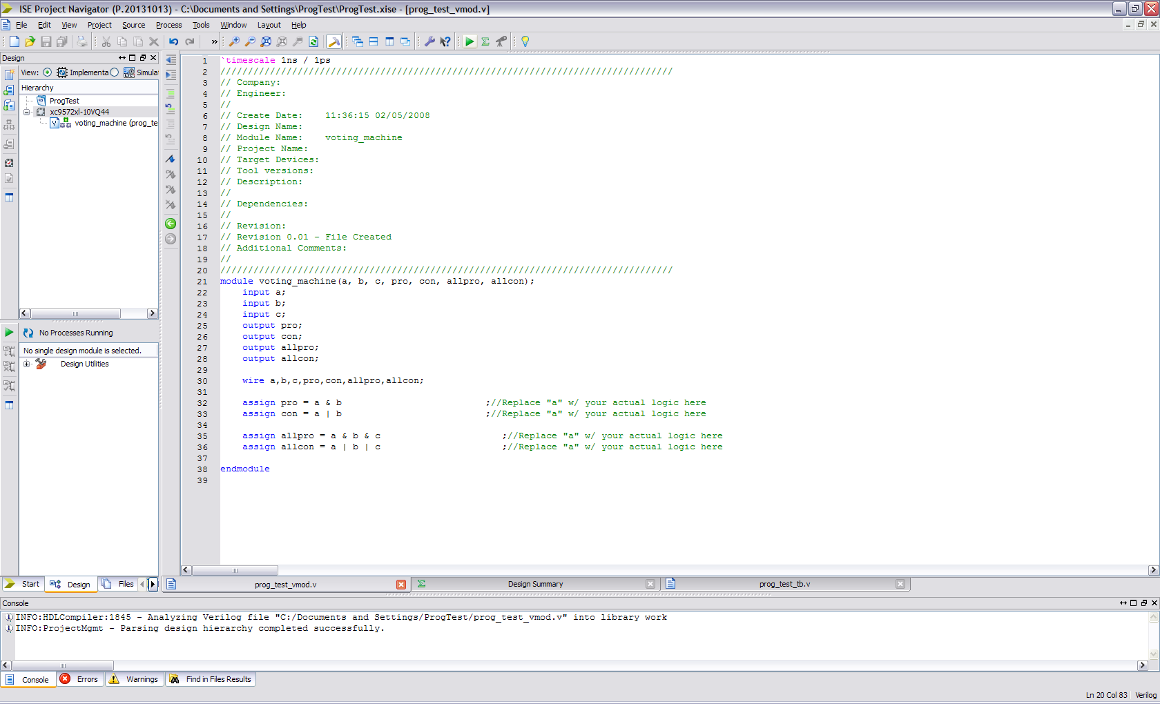

Repeat for test fixture code!
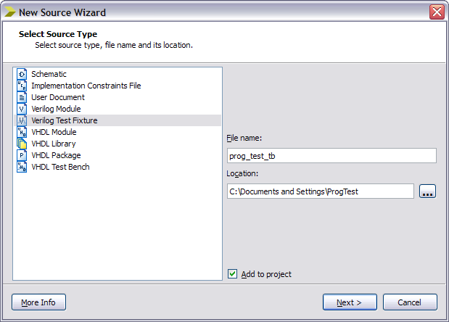
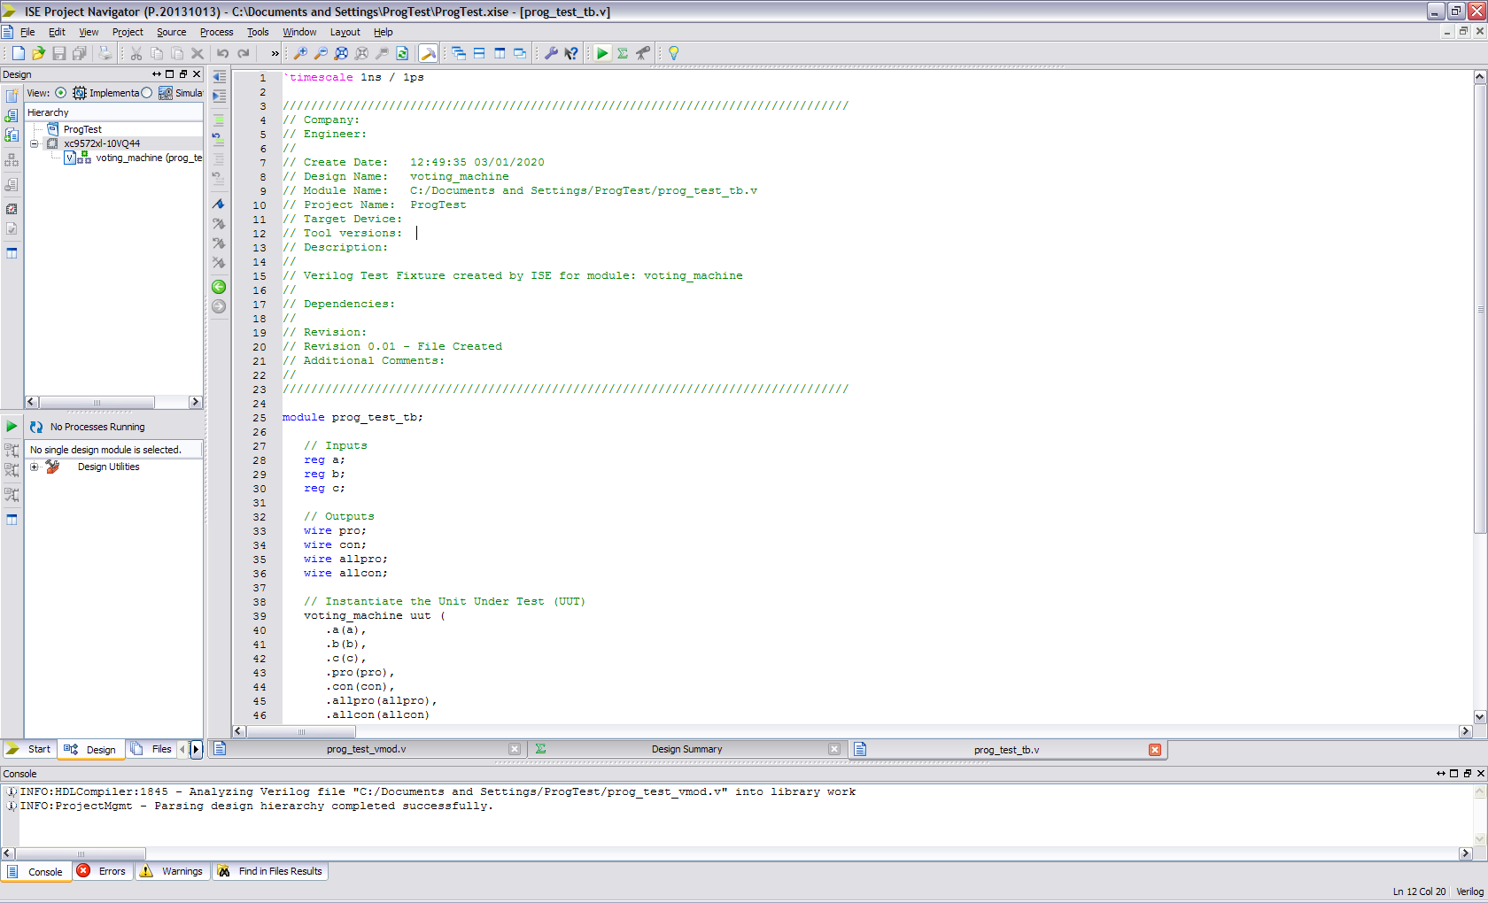
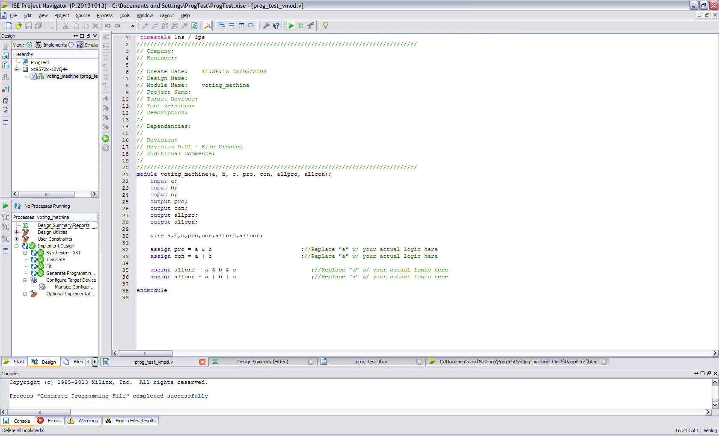 BUILD THE PROJECT!

Runs synthesize, translate, fit & makes .jed file for device!

Double click configure target device, this opens IMPACT. MAKE SURE YOU SELECT THE CORRECT .JED FILE!!! Double click Boundary scan, then right click to add XILINX device over “Right click to add JTAG chain…”
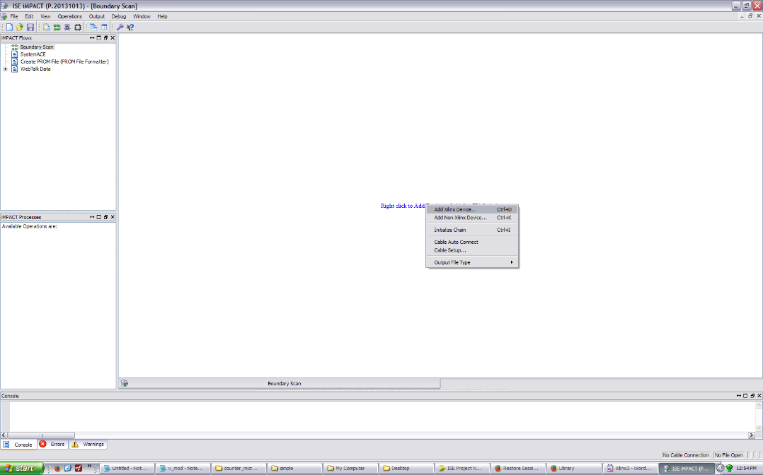

- SETUP POD, programming board, and chip –
  - Turn on 5V supply to programming board.
  - LED should light up
  - Plug in pod USB cable to computer
  - POD light should turn green
- PROGRAM CHIP!
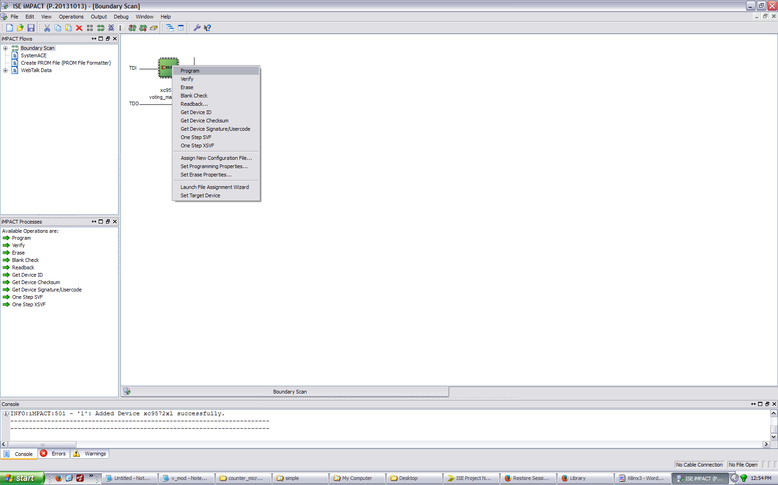
Should see:
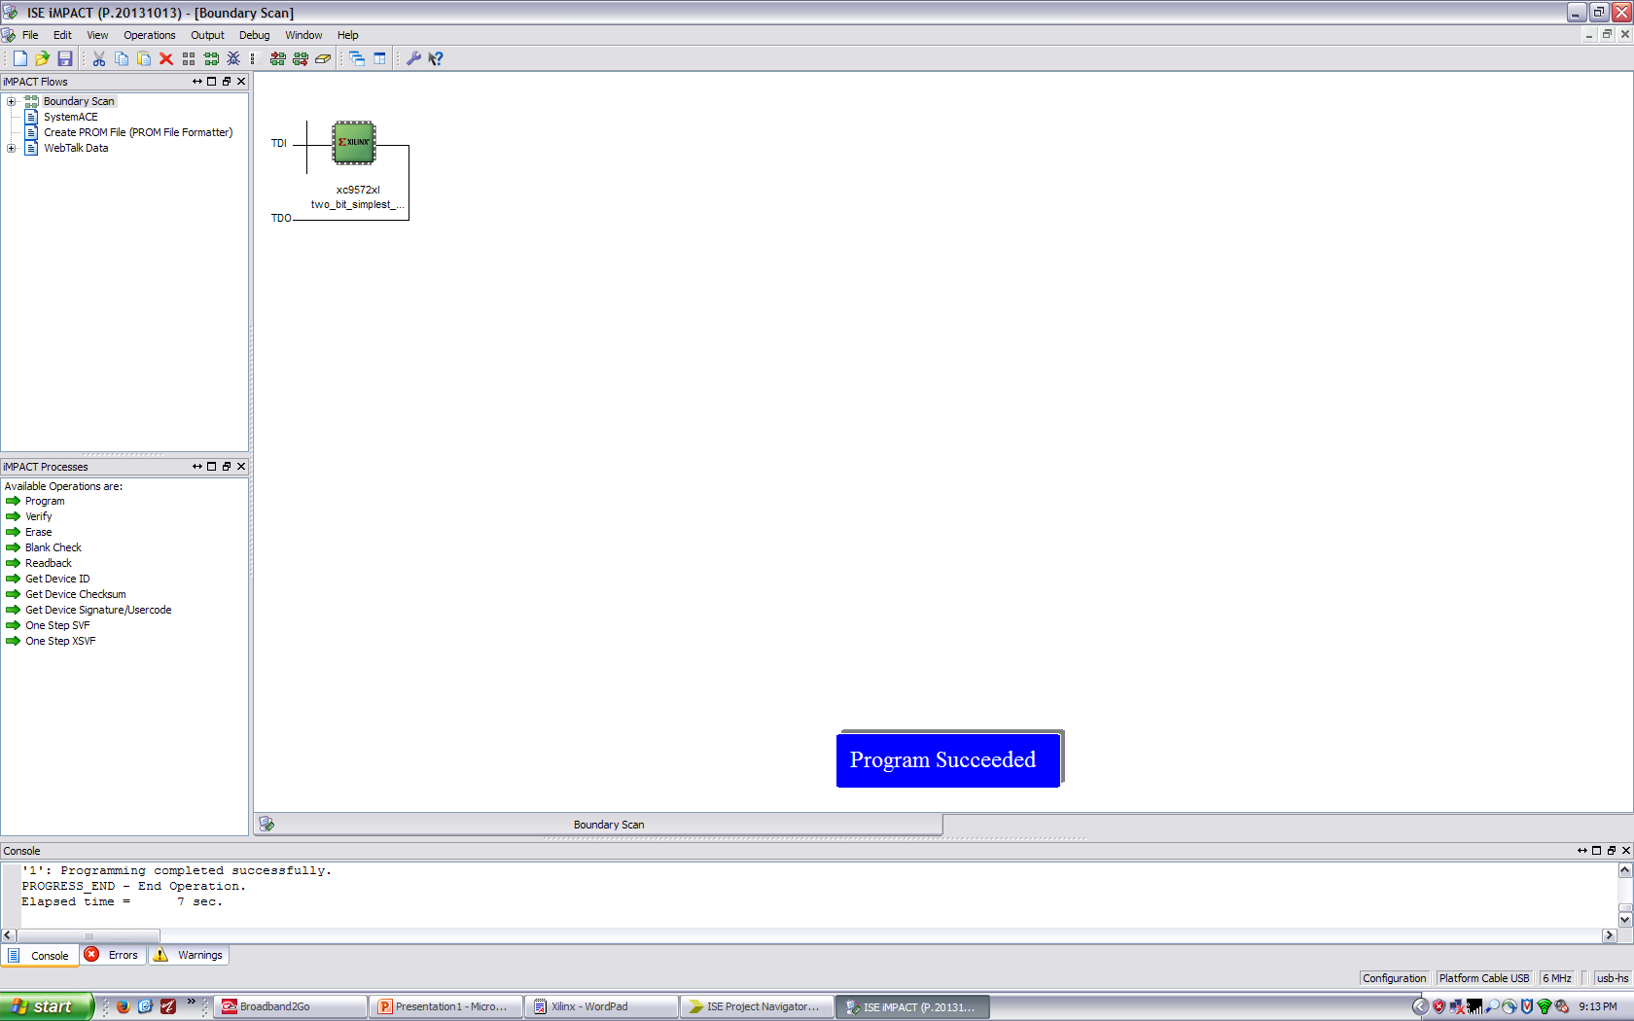
If you ever see error “Could not connect to cable device” this means the pod drivers are not installed correctly.
EASY 1-2-3!

PIN ASSIGNMENTS
Found this to work!!
https://www.xilinx.com/support/documentation/sw_manuals/xilinx11/pp_p_process_io_pin_planning_pre_syn.htm

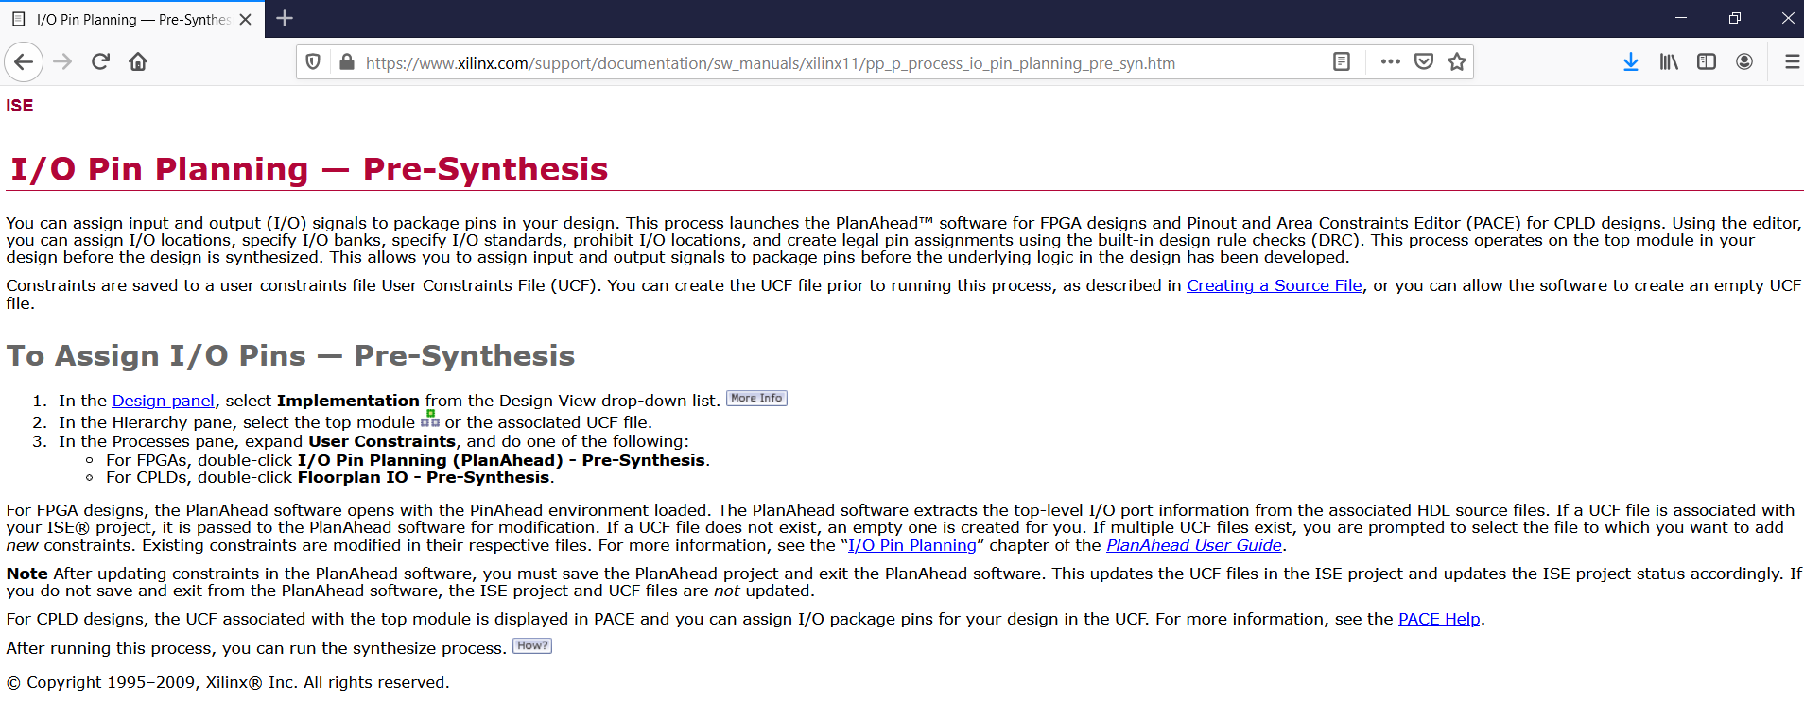
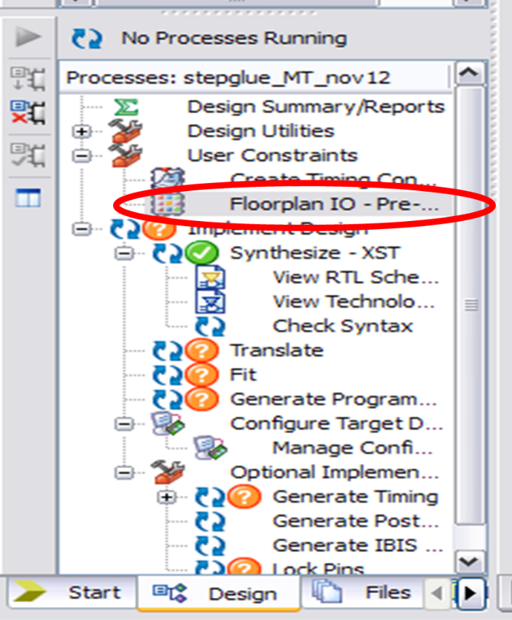
Double click the floorplan IO and PACE window comes up
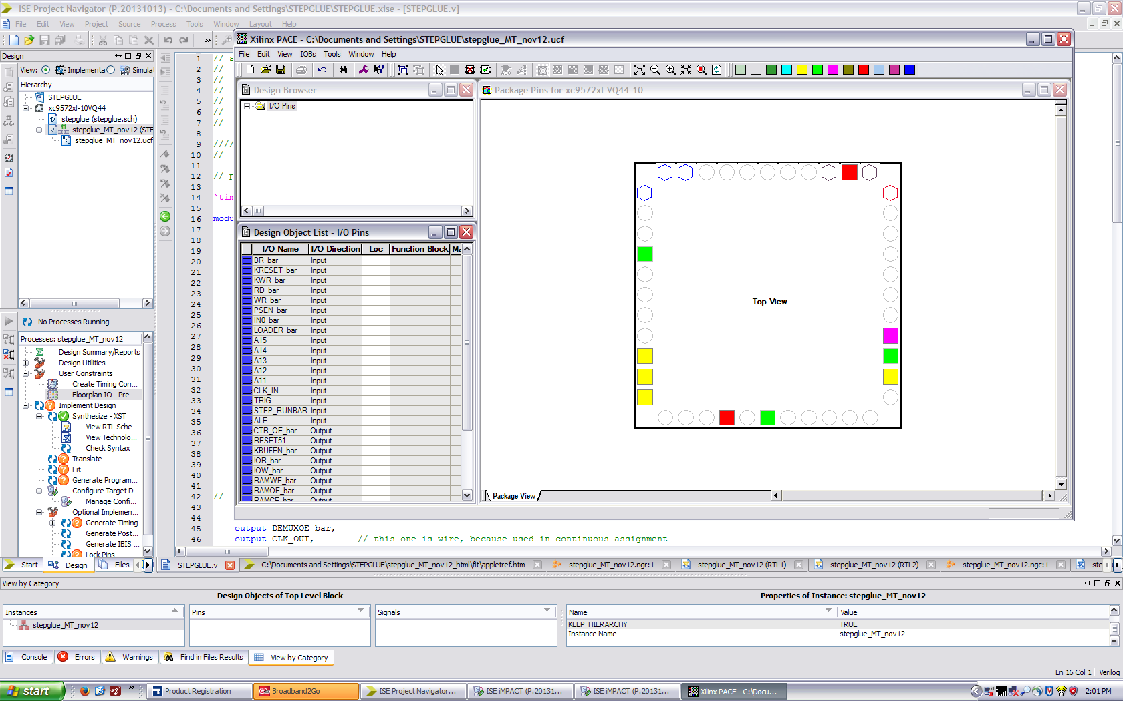
Under Loc just type the pin number. Ignore the drop box – it will autofill functional blocks – but if you just type a number it will assign as a pin.

